Report for version 1.2

Group 16

Chen Jinyi 1063692

Li Guanchi 1063864

Wang Yilun 1064067

Wei Zhangyu 1064082

Zhang Ye 1064211

In the latest version (version 1.2), we have made some changes and improvements to the project.

1. **Improved UI**

Beautify the UI.

1. Added temperature display.

The mobile UI related changes are as follow (figure 1)

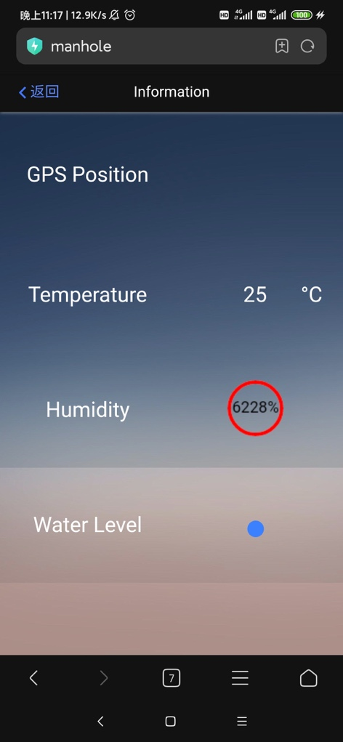

figure 1

The relevant UI changes on the PC side are as follows (figure 2)

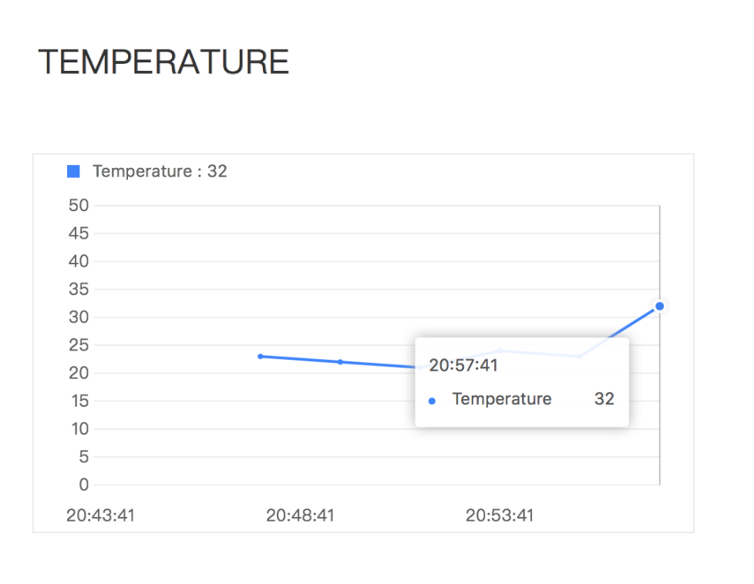

figure

1. Manhole cover selection page has been added after administrator login screen on the mobile client shown as follow (figure 3):

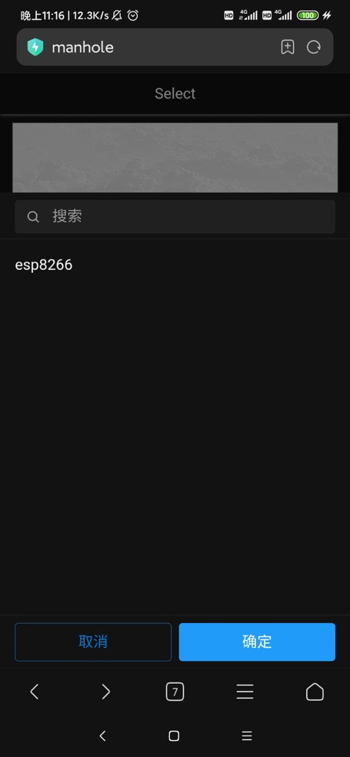

figure 3

1. **Add administrator**

An administrator is added in the operation background, and the background interface is as follows (figure 4)

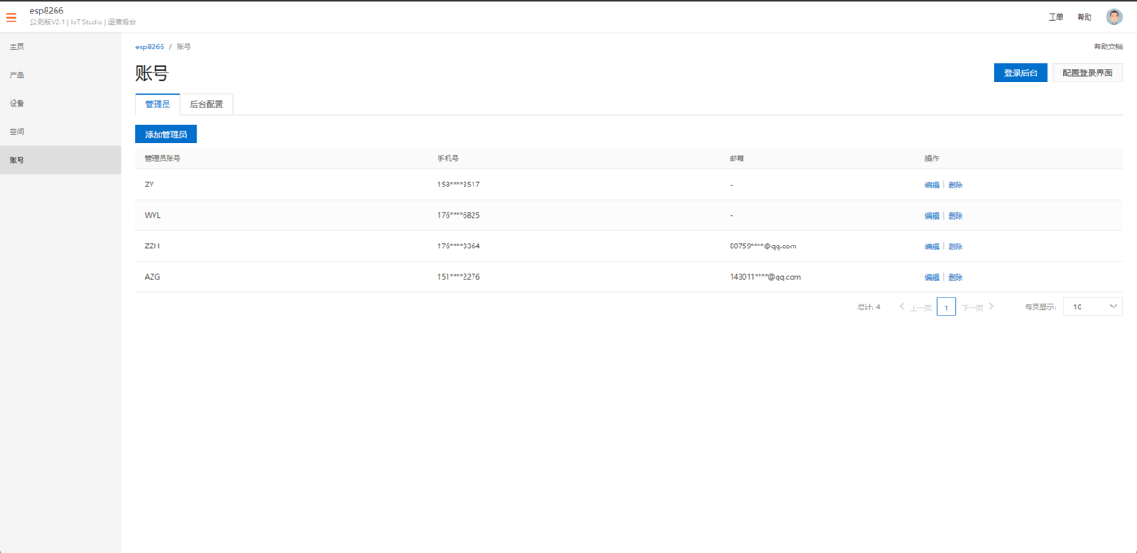

figure 4

These are all the changes we have made in the latest version (version 1.2). So far, users can use all the functions of this project normal.